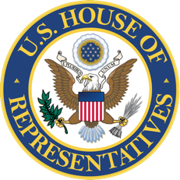

Internship Application
Office of Rep. Lucy McBath, Georgia’s Sixth District

- Applicant Information
Full Name:
Street Address:
City, State, Zip:
Permanent Address (if different than address above)

Email:
Phone Number:

- Applicant’s Additional Information
Desired Location(s)
Washington, DC Office
Sandy Springs District Office
If you selected DC, would you like to be considered for a Communications/Digital Internship?
Yes
No
Desired Session(s)
Summer 2021
Fall 2021
Spring 2022
Summer 2022
Fall 2022
Please indicate the dates you will be available to start and end your internship and your weekly availability between the hours of 9am-5pm

- Additional Information
Please use this box to write a brief paragraph about yourself, including the reasons why you would like to intern in a congressional office (250 words)

Please list specific legislative issues or areas of interest to you

- Academic Information
College or University

Is academic credit available for internships?
Yes
No
- Please complete if you are currently enrolled in College/University.
Year in School

Expected Graduation Date

Advisor’s Name and Email

GPA

Major

Activities/Honors

Names and Email Addresses of Three References

Thank you. Please save this completed document as a PDF and have your cover letter, resume, and writing sample ready as a single PDF file.

To submit, please email the two (2) files to interns.mcbath@mail.house.gov with the subject line "DC Office Internship Application" or "District Office Internship Application." If you are applying for both offices, please submit two separate applications with proper subject lines. We look forward to reading your materials.

